**PWD Command --** The pwd command (print working directory) writes the full pathname of the current working directory to the standard output.

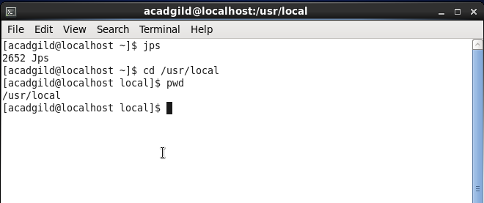

**TOUCH -** The touch command is a standard program for Unix/Linux operating systems, that is used to create, change and modify timestamps of a file.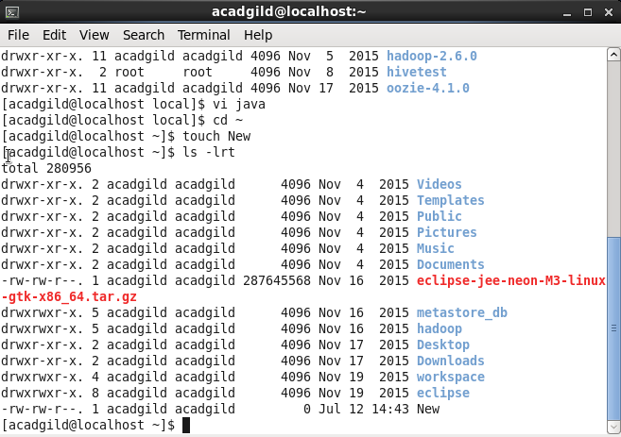

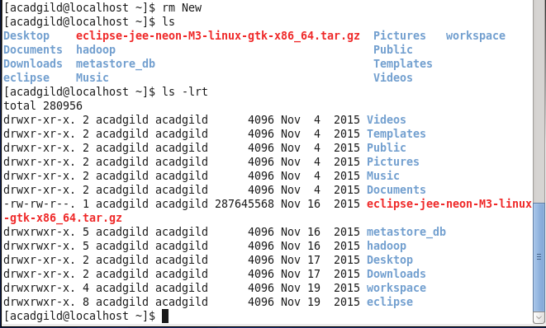

**MKDIR Command -**  It creates a new directory under the specified path

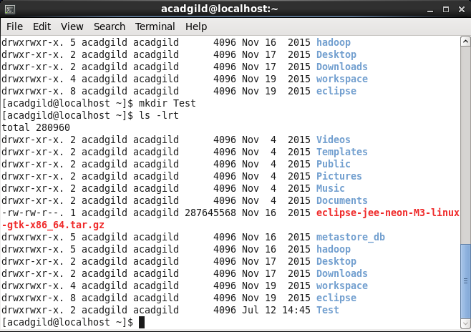

**ECHO-** Used to display the output to the command line or a file.



**CAT command-** Displays the contents of the file.

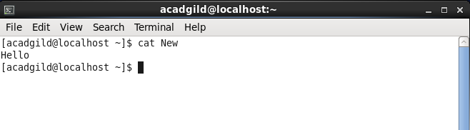

**WHICH Command-** To locate the program files and displays their path.

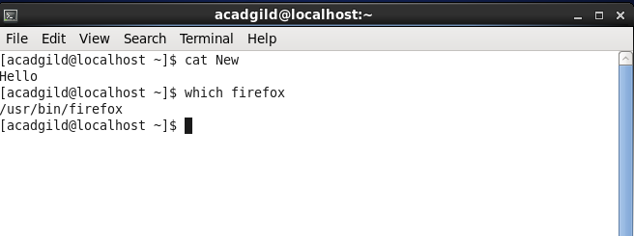

**CP –** copies the specified files from one location to other.

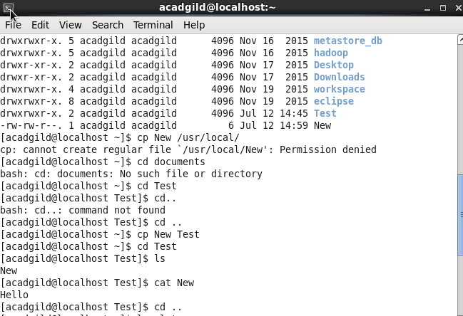

**MV -** mv renames file SOURCE to DEST, or moves the SOURCE file (or files) to DIRECTORY.

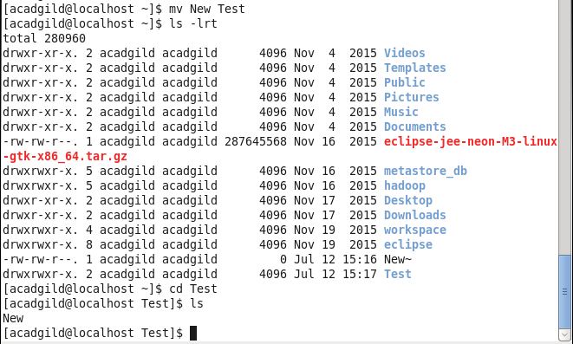

**DATE and CAL**

